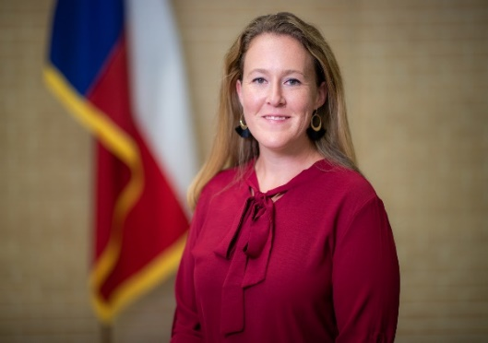

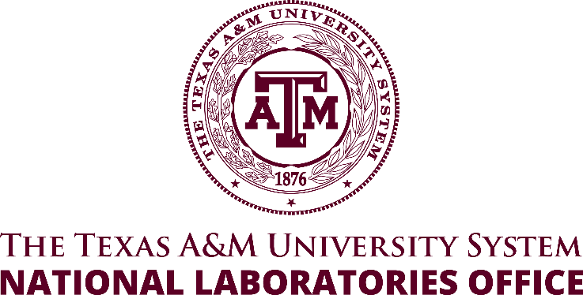

Janelle Salinas
Director of National Laboratory Workforce Development
for the National Laboratories Office

The Texas A&M University System

Janelle Salinas is the Director of National Laboratory Workforce Development. She has worked with the National Laboratories Office (NLO) since 2019. Her role has involved establishing management practices for contracts, financials, and workforce development. Janelle received her Batchelor of Science degree in Industrial Distribution from Texas A&M University in 2008, a focus in supply chain management and logistics. Janelle then completed her master’s in science in Project Management online through the University of Wisconsin-Platteville in 2013.

Salinas’ current position with the NLO helps to build lasting relationships with our national laboratory partners. The previous administrative experiences she has been involved with since joining the Texas A&M University System in 2010 assisted in positioning the National Laboratories Office in the place that it is today. Her professional career began in Houston within an oil drilling business, but she returned to College Station in 2010 to help manage the business functions of the Environmental Research Center of the Texas A&M Transportation Institute. Her various experiences within the System include working with Texas A&M Sponsored Research Services team, the Post Award Administration team, and management of the College of Engineering and Qatar campus research awards.

One of those awards helped to establish the National Laboratories Office. She now oversees workforce and employment pipeline development programs to enhance the effectiveness of Texas A&M University System in support of national laboratory partnerships and missions as they relate to national security and service.

