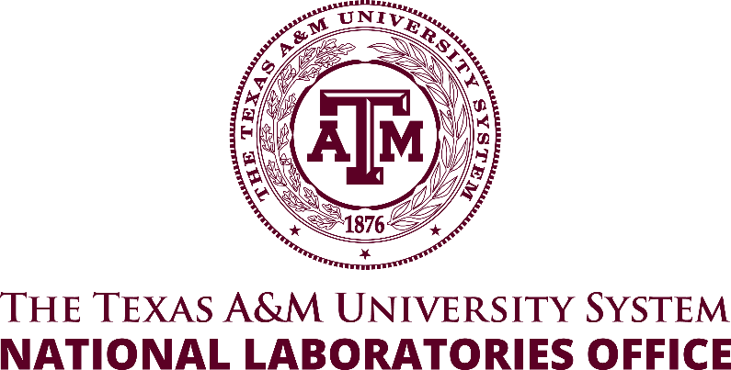
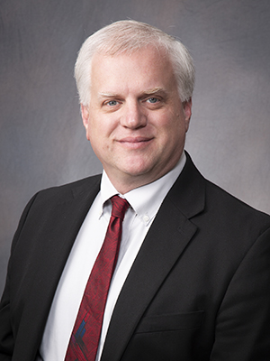

Sean M. McDeavitt, Ph.D.

Associate Vice Chancellor for National Laboratories

The Texas A&M University System

Professor, Nuclear Engineering

Texas A&M University

Dr. Sean M. McDeavitt is the Associate Vice Chancellor for the Texas A&M University System’s National Laboratory office. His multidisciplinary experience in nuclear, materials, and chemical engineering has equipped him with the flexibility to make leadership and research contributions in a diverse range of subjects. He earned his Ph.D. from the Purdue University School of Nuclear Engineering where his research focused on uranium-10 wt % zirconium (U-10Zr) alloy nuclear fuel for the Integral Fast Reactor; this involved handling pyrophoric metal and hydride powders, processing samples at high-temperatures, and characterizing the behavior of U-10Zr.

His professional career began at Argonne National Laboratory (ANL), where he worked from 1991 to the Fall of 2003. While at ANL, he earned an international reputation as a leader in nuclear materials research and development, especially in the areas of applied research for advanced nuclear fuel cycles, waste immobilization, and materials development for challenging environments. Between 1999 and 2003, he was the Section Manager for the Materials Development and Pyroprocess Development Sections. In the Fall of 2002, he served as a Visiting Professor at Purdue University; this marked the beginning of his transition to academia.

From August 2003 to August 2006, he worked at Purdue University as an untenured Associate Professor of Nuclear Engineering. He joined the faculty of Texas A&M University in the Fall of 2006 and has been a full professor of Nuclear Engineering since 2018. In 2014, he became the Director of the Texas A&M Nuclear Science Center (NSC), which operates a 1 MW TRIGA reactor and a 5 W AGN-201M reactor. In 2019, the NSC was renamed to the Nuclear Engineering & Science Center (NESC) and Dr. McDeavitt became the director of the NESC reactors and nuclear science research laboratories as well as the Nuclear Power Institute (NPI), which is a center focused on STEM education and workforce development. In September 2022, He became the Executive Director of NESC as he continued to position the reactor infrastructure and workforce development activities for further success. In May 2023, Dr. McDeavitt assumed the role of Associate Vice Chancellor for National Laboratories.

