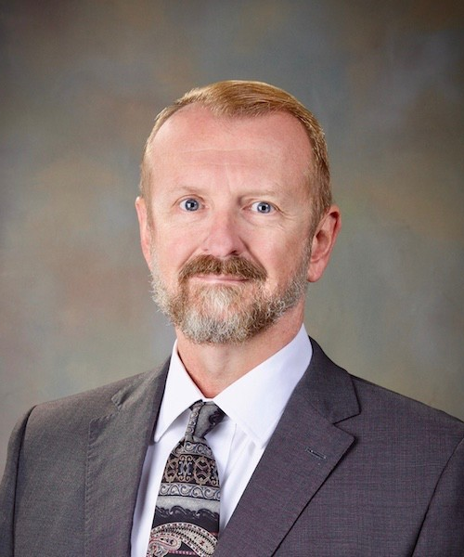

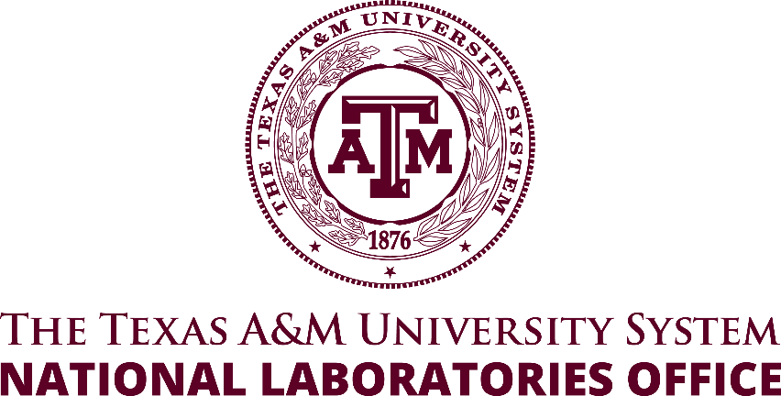

Arnoldo (Arnold) Muyshondt, Ph.D.

Assistant Vice Chancellor for National Laboratories

The Texas A&M University System

Adjunct Professor, Mechanical Engineering

Texas A&M University

Research Fellow of the Institute for Science, Technology and Public Policy

The Bush School of Government and Public Service, Texas A&M University

Dr. Arnoldo (Arnold) Muyshondt is the Assistant Vice Chancellor for the Texas A&M University System’s National Laboratory Office. His multidisciplinary background in engineering research and development as well as his strong leadership skills have equipped him with the flexibility to make leadership and research contributions in a diverse range of subjects. He earned his Ph.D. from the Texas A&M University Mechanical Engineering Department and his bachelor’s and master’s from the Texas Tech Department of Mechanical Engineering.

His professional career began in 1988 at Lockheed Martin (formerly General Dynamics) in Fort Worth, Texas where after receiving his master’s degree he served as a senior propulsion engineer. Dr. Muyshondt researched advanced propulsion systems and transitioned that research into operational aircraft models such as the F-35, F22 and F16 fighters. In 1992, Dr. Muyshondt went on to pursue his PhD in Mechanical Engineering at Texas A&M University. He graduated in 1995 and joined the University of Arkansas in Fayetteville, AR as a mechanical engineering faculty member. There he taught and conducted research. In the summer 1998 he traveled to Sandia National Laboratories as a visiting faculty member. That summer assignment turned into a 25-year career on-site at Sandia.

During his career at Sandia National Laboratories, Dr. Muyshondt served our nation by working on everything from underwater to space systems. His experience includes technical management, development of models for radiation effects on electronics, micro electro-mechanical systems (MEMS) tunable filters, thermal modelling of nuclear weapons components, synthetic aperture radar (SAR) pointing systems, underwater system development, satellite payload development, nuclear deterrence education, etc. He graduated from the Sandia National Laboratories Weapon Intern Program (WIP) in 2001.

In addition to his career at Sandia, Dr. Muyshondt has volunteered for over a decade for the National Council of Examiners for Engineering and Surveying (NCEES) to help write the mechanical engineering professional engineering licensure exam. He has over a decade and a half of volunteer experience with Accreditation Board for Engineering and Technology (ABET), a highly esteemed accreditation body that validates post-secondary degree programs, as a program evaluator for mechanical engineering and served as Commissioner for the engineering accreditation committee. Dr. Muyshondt is currently the member at large for the American Society of Mechanical Engineering (ASME) Committee on Engineering Accreditation and has served on that committee for over a decade. Dr. Muyshondt was a member of the Texas A&M Mechanical Engineering Industrial Advisory Panel from 2007 to May 2023.

He retired from Sandia National Laboratories in May of 2023 and moved to College Station to assume his role as Assistant Vice Chancellor for the Texas A&M University System National Laboratories Office.

